# 5/17/21 WS Solve Verification

I added additional tests to ensure my WS matrix is correct all for first test problem below

1. Q is self-adjoint
2. The eigen values of Q are real
3. The eigen values are ordered least to greatest
4. Reconstructing Q using $Q=W\overline{Q}W^{†}$ is the original Q
   1. L2-norm of the relative difference is 3 digits (probably not a concern)

I am reasonable sure my WS matrix is computed correctly and can move onto solving the sound-soft integral equation (EFIE) with an excitation defined by an arbitrary WS mode. The incident field is given by

$$ϕ_{WS,q}^{i}\left(r,ω_{0}\right)=\sum_{p=1}^{M}{W_{pq}\left(ω_{0}\right)ϕ_{p}^{i}\left(r,ω_{0}\right)}$$

$$ϕ_{p}^{i}\left(w,ω_{0}\right)=2kj_{p}\left(kr\right)Y_{p}(θ,ϕ)$$

Note the $2k$ which scales the amplitude of the incident field. This is incident field used to compute the scattering matrix so I am using the exact same form in setting up the incident field for the q-th WS mode.

The new incident field, $ϕ_{WS,q}^{i}\left(r,ω_{0}\right)$, is fed into my routines for solving the sound-soft IE.

IMPORTANT: in test problems 1 and 2, the test and source quadrature rules were not equivalent therefore causing the scattering matrix to not be unitary and symmetric and explains the significant imaginary components seen in the time delay. Notice this is the not the case in test problem 3 where the quadrature rules were made equivalent.

**Test Problem 1:**

Geometry: Flat circular plate $r=1$ with $\sim 15 elements/λ$ supporting $λ≥\frac{2}{3}$

Incident field: As defined above with $λ=1m$, $l_{max}=13≈2kr$

*WS mode 1 (shortest delay)*

Time delay = -0.9953954772517856 + 0.0020845537986733274im

Real part on left; Imaginary part on right

*WS Mode 196 (largest delay)*

Time delay = 0.001606321565132204 + 0.0002334168591909824im

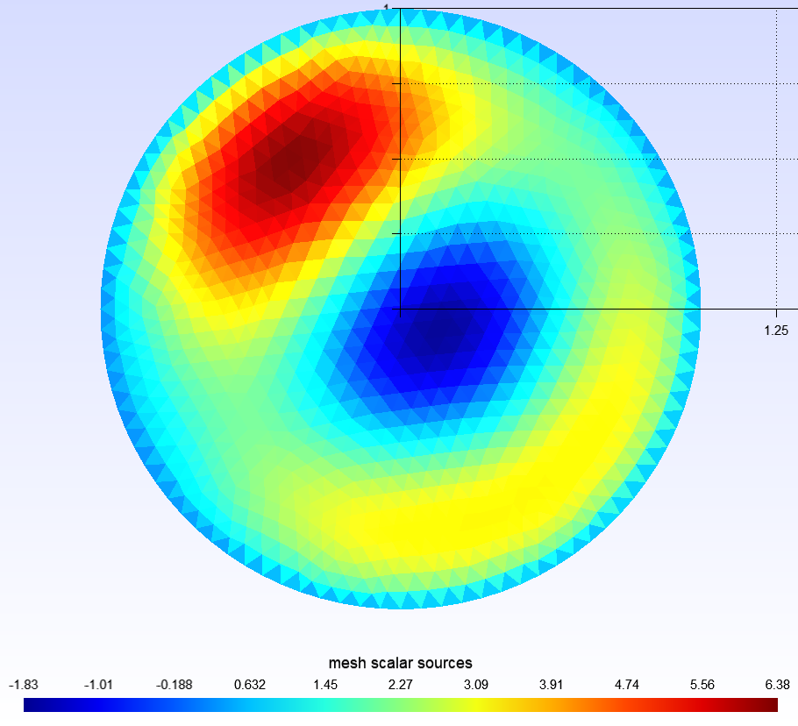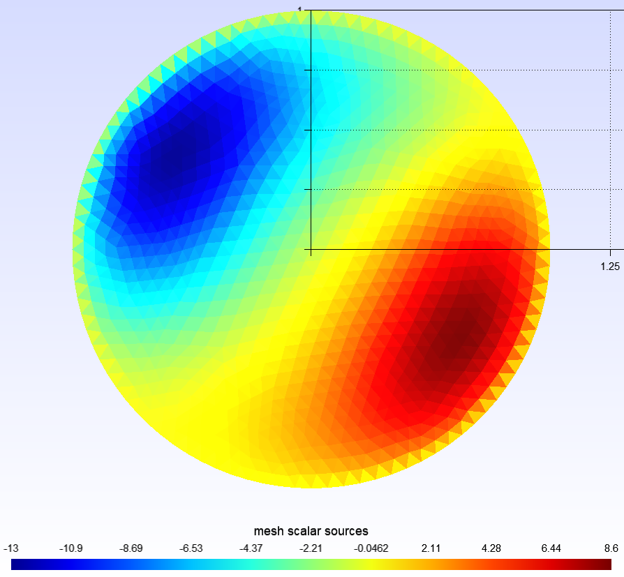

Real on left; imaginary on right

**Test Problem 2:**

Geometry: Flat plate 1m x 5m with 16 elements/1m supporting $λ≥0.625$ m

Incident field: As defined above with $λ=1$.8m, $l_{max}=18≈5k$

*WS Mode 1*

Time delay = -3.876744682477856 - 0.058368246504592394im

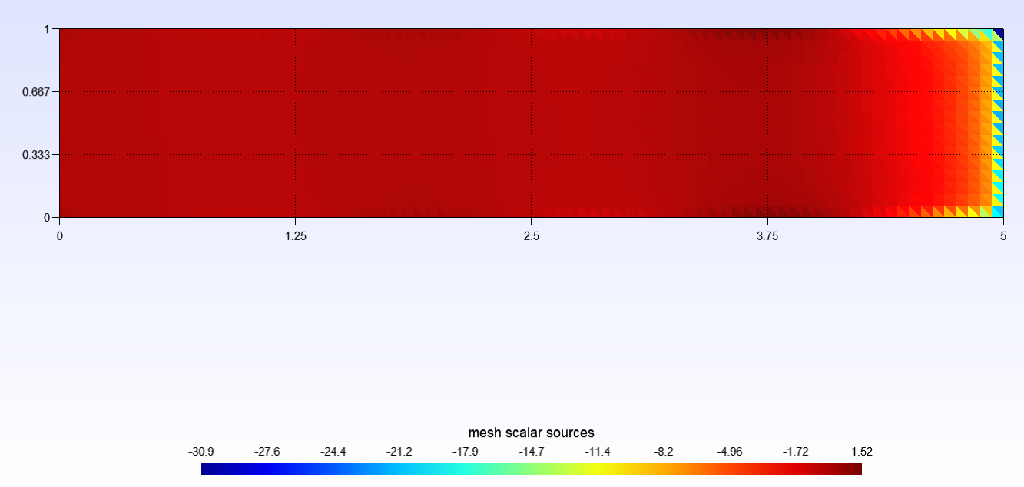

Real part

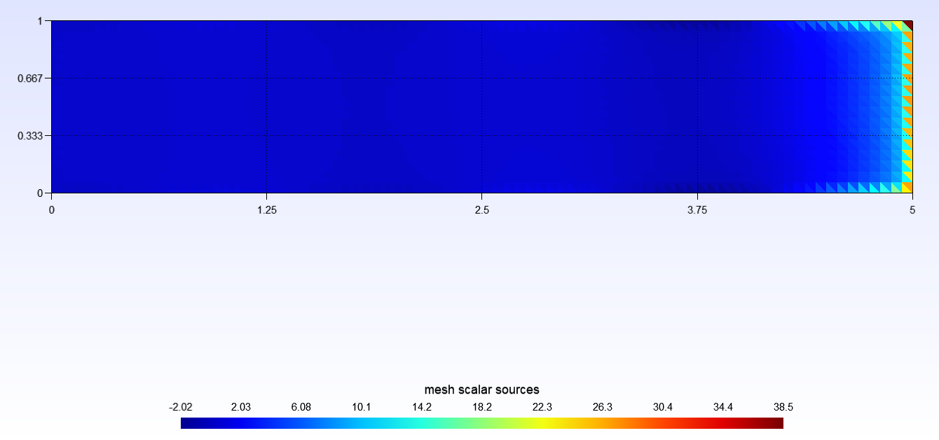

Imaginary part

*WS Mode 361*

Time delay = 0.008070315736364311 + 0.00030013382040804603im

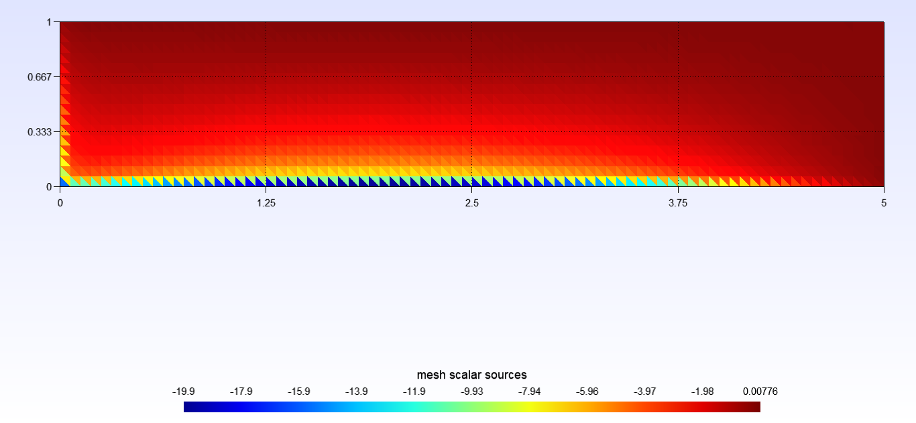

Real part

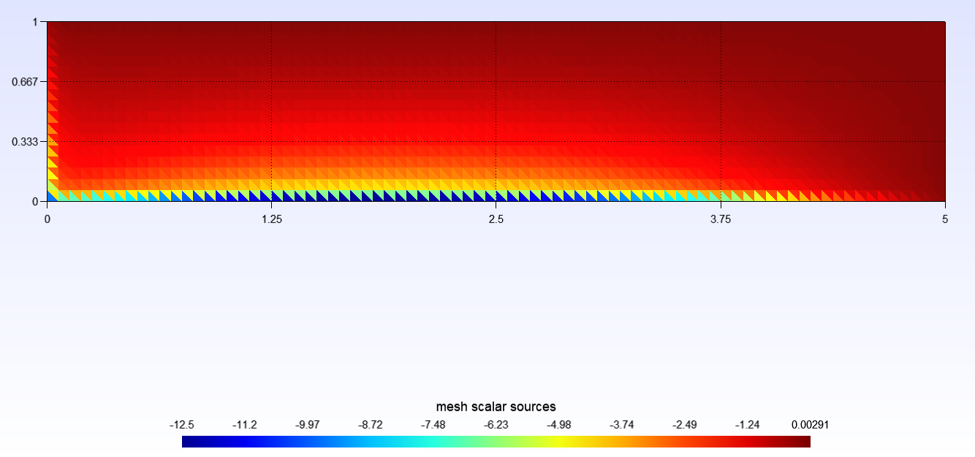

Imaginary part

**Test Problem 3:**

Same geometry as test problem 3, but the strip is centered at the origin.

Geometry: Flat plate 1m x 5m with 16 elements/1m supporting $λ≥0.625$ m

Incident field: As defined above with $λ=2$ m, $l_{max}=16≈5k$

*WS Mode 1*

Time delay = -1.999887935483245 - 4.646994387226436e-10im

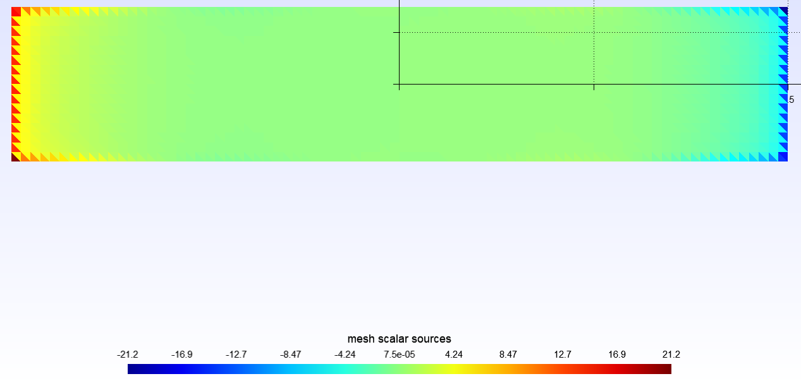

Real part

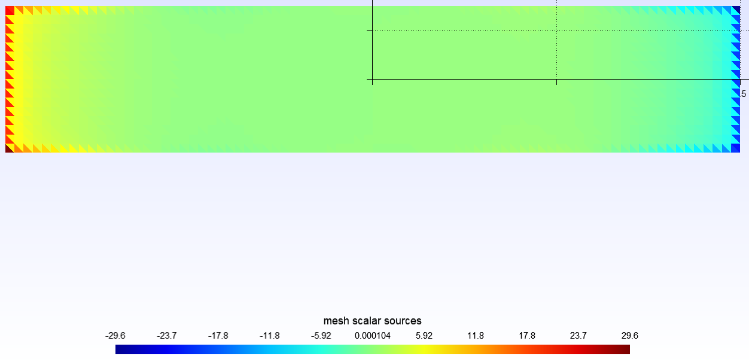

Imaginary part

*WS Mode 289*

Time delay = 0.0003754600766265172 + 2.0924290421173208e-14im

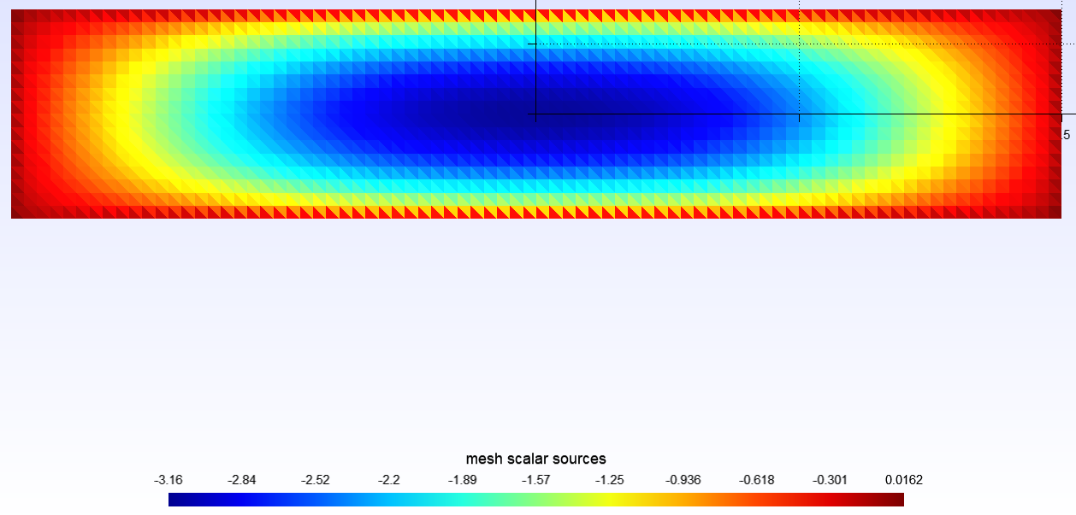

Real part

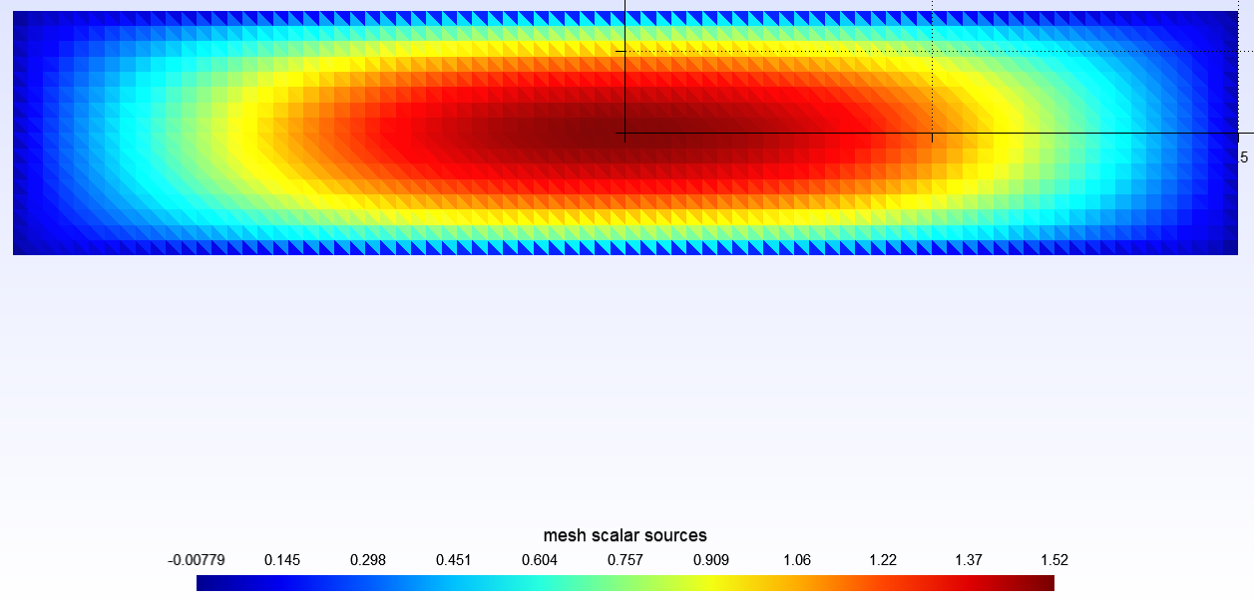

Imaginary part

**Test Problem 4**

Geometry: Sphere radius = 1m

Incident field: As defined above with $λ=2.1$ m, $l_{max}=12$

*WS Mode 1*

Time delay = -1.9940933371297502 + 1.1360640414100827e-11im

*WS Mode 169*

Time delay = -3.1924603515804252e-12 + 1.1158283975169697e-23im

**Test Problem 5**

Geometry: Sphere radius = 2m

Incident field: As defined above with $λ=4.1$ m, $l_{max}=8$

*WS Mode 1*

Time delay = -3.991006984831321 + 8.689868713623138e-12im

*WS Mode 81*

Time delay = -2.9714847331806543e-5 + 2.8953624472873465e-16im

**Convergence Tests**

To verify the WS modes converged with respect to maximum L (spherical harmonic degree), I ran test problem 3 with max L of 16 and 17 and the eigen values are very similar between the two indicating convergence is achieved. See image below for some of the eigen values.

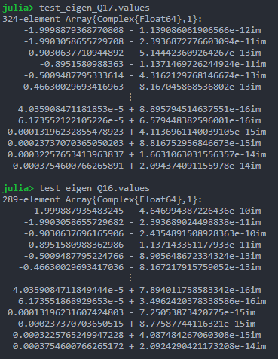

**Conclusions**

Overall, I believe these results look good and are valid. For the circle, my intuition tells me the shortest time delay is correct as the waves appear to bounce off the perimeter of the circle (which is centered at (0,0)). For the largest delay on the circle, maybe that makes sense because there appear to be hotspots closer to the origin therefore the wave is traveling farther. For the strip geometry results, my intuition tells me that the shortest time delay will occur when all the wave bounces off the right end of the plate so those results might make sense. For the largest delay on the strip it’s not so clear, but I would expect bouncing off the corner at (0,0) would give a time delay of 0 and the largest delay is not much greater than zero. For test problem 3, I believe the results tell a similar story.

Take test problem 3 as an example. The reason there is not a time delay of -5 for the WS mode 1 is because that would be the expected time delay if the incident and reflected fields were restricted to the two-dimensional plane in which the plate lies. Since this is a three-dimensional problem, waves travel with components orthogonal to the plate’s surface. Consider an incident wave traveling orthogonal to the plate’s surface with a corresponding scattered wave that travels along the same path. This field would have a time delay of 0, therefore the total time delay when considering all possible incident fields will not be -5, but somewhere between -5 and 0. One requirement to have a delay of exactly -5 is full suppression of all incident fields orthogonal to the plate, which I believe is unlikely the case.

I think my hypothesis above is confirmed in test cases 4 and 5 since spherical waves are incident on a sphere and therefore entirely orthogonal to the surface. Now we see similar behavior as a stick in two-dimensions. The smallest WS mode has a time delay of twice the radius meaning the waves are incident on the sphere and reflect away, thus are not traveling a distance of twice the radius. Note for all analyses the speed of the incident waves is 1 m/s.